Functional Requirement Document – SAP BTP CAP + Fiori
Field | Details
Project Name | IT Asset Lifecycle Manager
Version | 1.1
Date | 13-Oct-26
Author | Functional Consultant (MM)
Sponsor | CFO
Business Owner | Head of Procurement

Document Revisions
Date | Version | Changes
15-Sep-26 | 0.1 | Initial draft
08-Oct-26 | 1 | Final – post Fit-to-Standard workshops
13-Oct-26 | 1.1 | Added Manager role, KPI dashboard visualizations, and PDF export/email/download requirements

Approvals
Role | Name | Signature | Date
Project Sponsor | R. Sharma | ___ | ___
Business Owner | A. Patel | ___ | ___
Project Manager | K. Verma | ___ | ___
System Architect | D. Singh | ___ | ___

Executive Summary
Many organizations struggle to maintain accurate records of IT hardware assets throughout their lifecycle. Assets are often misplaced, transferred without proper tracking, not returned during employee offboarding, or retired without maintaining historical ownership records.
This project builds an IT Asset Lifecycle Manager on SAP BTP using the Cloud Application Programming (CAP) Model (Nofde.js) with a SAP Fiori Elements frontend, deployed as an MTA application on SAP BTP Cloud Foundry.

Expected Outcome:
- Centralized asset life cycle management.
- Improved asset visibility and accountability.
- Automated tracking of asset movements.
- Enhanced maintenance and audit management.
Improved management visibility through visual KPI dashboards and shareable PDF reports.
- Reduced manual effort and data inconsistencies.

Scope
- CAP backend service using Node.js with CDS models.
- SAP Fiori Elements List Report and Object Page.
- OData V4 services exposed using CAP.
- SAP HANA Cloud persistence.
- XSUAA authentication and role-based authorization.
- HTML5 Application Repository for Fiori hosting.
- Asset, employee, category and vendor master management.
- Asset assignment, transfer and return.
- Maintenance, retirement and compliance-driven archival.
- Immutable ownership/lifecycle history.
- Distribution-date validations.
- Admin, Manager and User roles.

Out of Scope
- Native mobile application.
- RFID/GPS-based physical tracking.
- Barcode scanner hardware integration.
- Automated financial depreciation.
- SAP Asset Accounting integration.
- Custom ABAP development.
- Multi-tenant SaaS model.
- AI-based lifecycle prediction.
- Automatic HR synchronization with SAP SuccessFactors.
- Physical deletion of archived/audit records.
- Full procurement approval workflow.

Architecture Overview
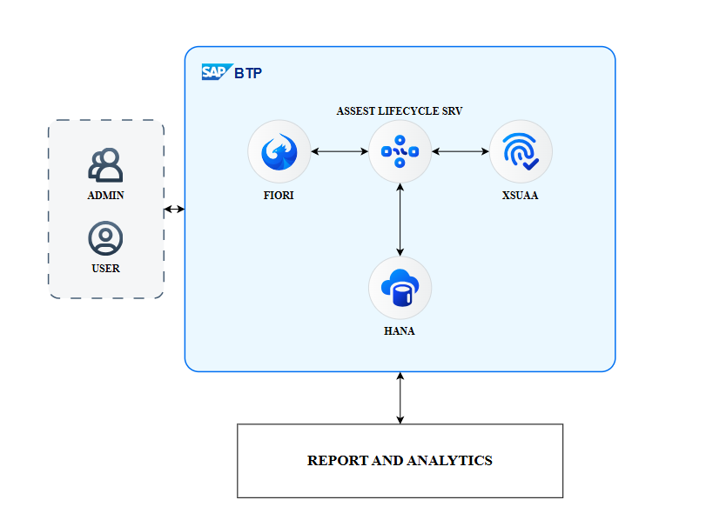

Data Models
Entity | Key Fields | Description
Employees | employee_id, full_name, email, phone, location, status | Employee master for asset ownership and assignments
AssetCategories | asset_category_id, name, lifespan_months | Hardware category master
Vendors | vendor_id, name, email | Suppliers and service providers
Assets | asset_id, asset_tag, serial_number, purchase_date, purchase_cost, status, current_holder_id, first_distribution_date | Central hardware inventory and current state
AssetAssignments | assignment_id, asset_id, employee_id, assigned_date, expected_return_date, actual_return_date, assignment_status | Tracks each asset possession period
OwnershipLedgers | ledger_id, asset_id, action, from_employee_id, to_employee_id, transition_date | Immutable ownership and lifecycle ledger
MaintenanceRecords | maintenance_id, asset_id, service_vendor_id, type, reported_date, completed_date, status | Repair and service tracking
ArchiveRecords | archive_id, asset_id, archived_at, archived_by, reason, disposal_method | Retirement, disposal, and compliance archival evidence

Service Layer
Service | Entities Exposed | Annotations | Authorization
AssetAdminService | Assets, Employees,Categories, Vendors, Assignments, History, Maintenance, Retirement, Archive | OData V4; @requires: 'Admin' | XSUAA Role: Admin
AssetUserService | Assets, AssetAssignments, AssetHistory | OData V4; @requires: 'User' | XSUAA: User
AssetManagerService | Assets, Assignments, History, Maintenance, Dashboard KPIs, Reports | OData V4; @requires: 'Manager' | XSUAA Role: Manager; authorized read/report access

Functional Requirements
FR-001 | Admin can create and maintain hardware assets | Critical | Unique asset/serial number; category and procurement date mandatory; initial status AVAILABLE
FR-002 | Authorized user can view hardware inventory | Critical | List Report displays assets with status/category/owner/location filters
FR-003 | Admin can assign an available asset to an employee | Critical | Employee active; asset AVAILABLE; owner/status updated
FR-004 | Validate distribution date against procurement date | Critical | Distribution Date cannot be earlier than the Procurement Date
FR-005 | Admin can transfer an assigned asset | Critical | Old assignment closed; new assignment; owner and history updated
FR-006 | Admin can return an assigned asset | Critical | Owner cleared; AVAILABLE; assignment/history updated
FR-007 | Maintain immutable ownership history | Critical | Lifecycle events create ledger entries; entries cannot be changed/deleted
FR-008 | Send eligible assets for maintenance | High | Maintenance record; status MAINTENANCE; ledger update
FR-009 | Complete maintenance | High | Record completed; eligible asset returns to AVAILABLE
FR-010 | Retire an asset | Critical | Assigned asset rejected; reason/date captured; status RETIRED
FR-011 | Archive eligible retired asset | Critical | No physical delete; ARCHIVED status; archive/history records
FR-012 | Prevent archive of assigned assets | Critical | Archive rejected until return
FR-013 | Role-based Admin/User authorization | Critical | Admin lifecycle access; User permitted read access
FR-014 | Role-based Admin/Manager/User authorization | High | Admin: lifecycle/master-data administration; Manager: authorized dashboard, reporting/export and permitted operational access; User: permitted read access
FR-015 | User views permitted history | High | History read-only
FR-016 | Admin maintains categories | Medium | Create/update; inactive category unavailable for new asset
FR-017 | Admin maintains vendors | Medium | Vendor selectable for procurement/maintenance
FR-018 | Search and filtering | Medium | Asset No., Serial, Category, Status, Owner, Vendor, Location
FR-019 | English UI using i18n | Medium | Labels maintained through i18n resource bundle
FR-020 | Responsive application | Medium | Desktop/tablet Fiori responsive layouts
FR-021 | Admin and Manager can view a role-appropriate dashboard with pictorial KPI representations | High | Display relevant KPIs as charts/graphs and/or visual indicators; KPI values and underlying records must reflect current authorized data; User role does not gain dashboard access unless explicitly authorized.
FR-022 | Admin and Manager can export permitted reports and asset data to PDF | High | PDF output includes report title, generation date/time, selected filters, column/chart labels and the data visible to the requesting role; export respects authorization and applied filters.
FR-023 | Admin and Manager can email a report/export | High | User selects an authorized report and valid recipient(s); system sends the generated PDF as an attachment or approved secure link; show success/failure status and do not expose unauthorized data.
FR-024 | Admin and Manager can download generated reports/exports | High | Provide a download action for the generated PDF; the file must open as a valid PDF and contain the same filtered data shown in the report.
FR-025 | Enforce role-based access for Admin, Manager and User | Critical | Admin retains authorized lifecycle/master-data administration; Manager receives dashboard, reporting, export and only explicitly permitted operational read access; User retains existing permitted asset/assignment/history access. Deny unauthorized service and UI actions.
FR-026 | Allow dashboard KPI views and report exports to use authorized filters | High | Where filters are available, apply the same date/status/category/location and other supported filters consistently to KPI visuals, report previews, PDF downloads and emailed reports.

Fiori UI Requirements
Screen | Template | Key Elements
Asset List | List Report | Core asset columns; search and business filters
Asset Detail | Object Page | Header plus General, Procurement, Assignment, Maintenance, History, Retirement facets
Asset Assignment | Object Page + Action | Assign; employee; distribution date; validation→ link appears in Invoice facet
Asset Transfer | Object Page + Action | Current owner; new employee; transfer date
Asset Return | Object Page + Action | Return date and remarks
Maintenance Detail | Object Page /Facet | Type, issue, vendor, status, resolution, completion
Asset History | Object Page Facet | Read-only action, owners, status transition, actor/date
Retirement | Object Page + Action | Reason, date, condition and disposal
Archive | Object Page + Action | Reason/compliance reference; eligible assets only
Admin Dashboard | Fiori dashboard / analytical page | Pictorial KPI cards/charts for authorized asset lifecycle metrics; filters; navigation to relevant asset lists
Manager Dashboard | Fiori dashboard / analytical page | Role-appropriate KPI cards/charts; authorized filters and drill-down; no admin-only actions
Reports & Export | Report view / action | Preview permitted data; Export PDF; Download PDF; Email PDF/report; display validation and delivery status

Integration Requirements
# | Source → Target | Method | Frequency | Data
INT-01 | S/4HANA → CAP | OData v2 (via Destination) | 15 min (scheduled) | PO header + items, GR data
INT-02 | CAP → DIM | REST API (SAP BTP) | On-demand (upload) | Invoice PDF files
INT-03 | CAP → S/4HANA | OData v2 (via Destination) | On-demand (action) | Invoice status update (if needed)
INT-04 | CAP → SAP Notification Service | REST API | On-demand | Email/InApp notification to vendor
INT-05 | CAP → SAP Notification/Email Service | Approved email API | On-demand | Generated PDF report or approved secure download link; delivery result

Destination Configuration
Destination | Type | Target | Auth
S4HANA_PROD | HTTP | S/4HANA FQDN | Basic (service user)
S4HANA_QAS | HTTP | S/4HANA QAS FQDN | Basic (service user)

Security & Authorization
Aspect | Requirement
Authentication | OAuth 2.0 via XSUAA (Cloud Foundry); SSO with SAP S/4HANA (SAML)
Roles | AdminRole (lifecycle/master-data administration); ManagerRole (authorized dashboard, reports, exports and permitted operational access); UserRole (permitted asset/assignment/history access)
Authorization in CAP | CAP service-level role checks and record-level filtering where applicable; Manager access must be explicitly granted and must not inherit Admin privileges
Data Encryption | TLS 1.2+ in transit; HANA Cloud native encryption at rest
Audit | Log report generation, PDF export/download and email actions, including actor, timestamp, report type and outcome; do not log sensitive report contents

Non-Functional Requirements
ID | Requirement
NFR-001 | Response time: ALP initial load < 3s (95th percentile)
NFR-002 | Concurrent users: 200 (peak)
NFR-003 | Availability: 99.5% (business hours)
NFR-004 | Data retention: Invoice attachments 7 years
NFR-005 | Compliance: India DPDP Act 2023 (data residency in ind1 region)
NFR-006 | CI/CD: Git-based pipeline via SAP Continuous Integration & Delivery
NFR-007 | Dashboard performance: KPI visuals should render within 3 seconds at the 95th percentile under the stated peak load, excluding unusually large filtered result sets.
NFR-008 | Export performance and integrity: PDF generation must complete within 10 seconds for standard reports of up to 5,000 rows; larger exports must provide a clear progress/status indication or controlled failure.
NFR-009 | Email delivery: report email requests must return a clear accepted/success/failure status; transient failures must be logged and safely retryable without sending duplicate emails.
NFR-010 | Security: dashboard queries, PDF downloads and emailed reports must enforce the same role and data-access rules as the application; download links, if used, must be access-controlled and time-limited.
NFR-011 | Usability and accessibility: charts must have clear titles, legends, labels and a non-colour-only means of distinguishing values; provide a tabular or textual equivalent for key KPI values.
NFR-012 | Auditability: log export and email events with requesting user, timestamp, selected report/filters, recipients where applicable, and outcome, without storing report contents in application logs.

BTP Services & Resources
Service | Plan | Purpose
SAP HANA Cloud (DB) | Standard, 4 GB | Primary persistence
XSUAA (CF) | Application | Auth & roles
SAP Destination | Standard | Connectivity to S/4HANA
HTML5 Application Repository | Standard | Fiori app hosting
SAP Document Information Management | Standard | File storage
SAP BTP Logging | Standard | Application logs
Cloud Foundry Runtime | 1 GB memory per app | CAP service hosting

Deployment (MTA)
Module | Type | Description
db | HANA Cloud DB | CDS model deployment, migrations
srv | Node.js (CAP) | Backend service, OData v4
ui | HTML5 (Fiori) | Frontend application
mta.yaml | MTA descriptor | Ties modules + service bindings

Testing Strategy
Phase | Scope | Tools
Unit | CAP service logic, CDS validations | @sap/cds test framework, Jest
Integration | OData endpoints, Destination calls, DIM upload | Postman / test.http
UI | Fiori app flows, responsive, i18n | Manual + SAP Fiori Test Automation
Security | Role enforcement, auth flows | XSUAA test, penetration test
UAT | End-to-end business scenarios | Business users on QAS
Dashboard & Reports | KPI calculations/visuals, PDF generation, download, email delivery, filters and role restrictions | Automated service tests, UI tests, email integration tests, role-based negative tests

